**Experiment -3.3**

**Student Name: Sandhya Kumari UID: 22BDO10074**

**Branch: CSE(DevOps) Section/Group: 22BCD-1/B**

**Semester: 4th Date of Performance:06/03/24**

**Subject Name: Git and GitHub Subject Code: 22CHS-293**

1. **Aim/Overview of the practical: Work with your history in Git.**
2. **Task to be done:** - changing the last commit ,changing multiple commit messages, splitting commits and squashing commits.
3. **Steps for experiment/practical:**

* **Create a New Git Repository:** First, let's create a new directory and initialize it as a Git repository.

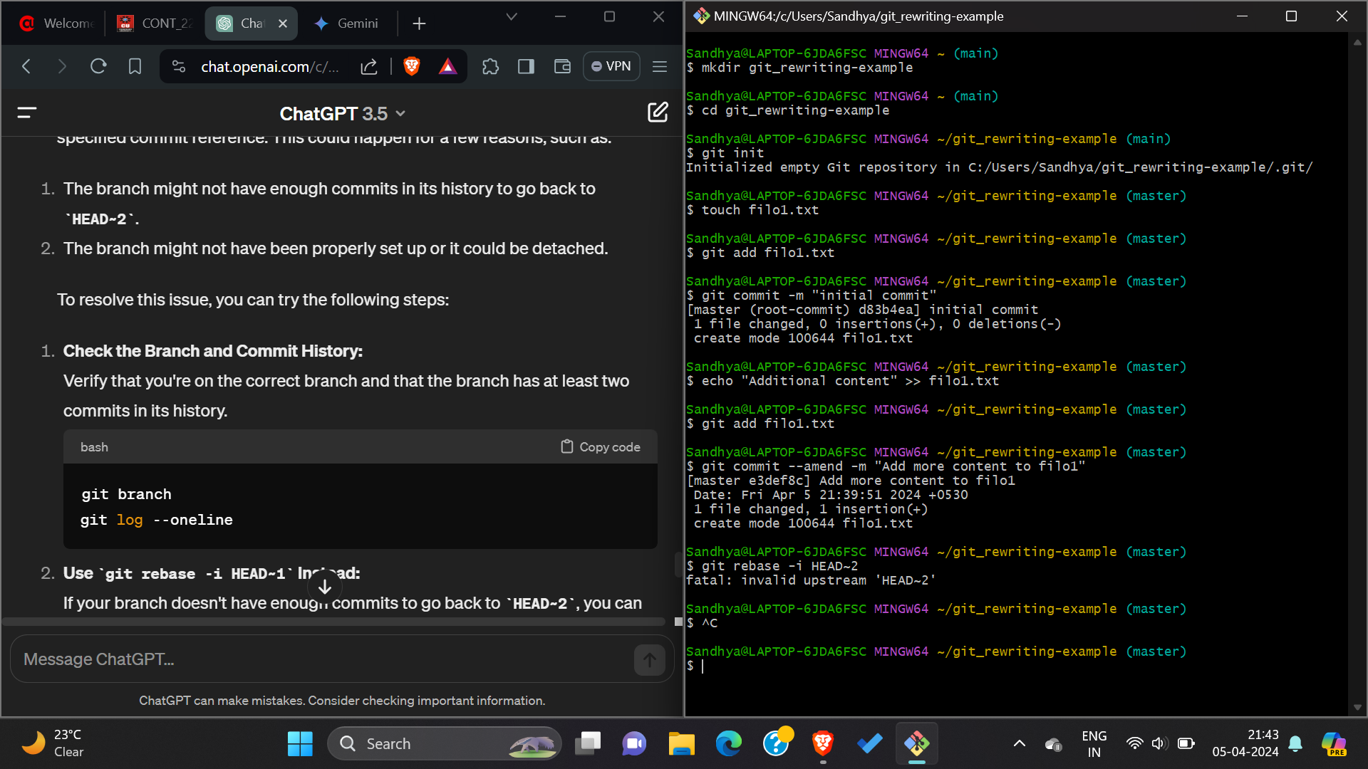

* **Make Some Commits: Create some files and make some commits.**



* **Amend the Last Commit: Let's say we forgot to include something in the last commit. We can amend it. Command (git commit –amend)**



* **Change Commit Message: Now, let's change the message of the last commit.**



* **Rebase to Squash Commits: Next, let's rebase to squash the last two commits into one.**

**Command: git rebase -i HEAD~2**

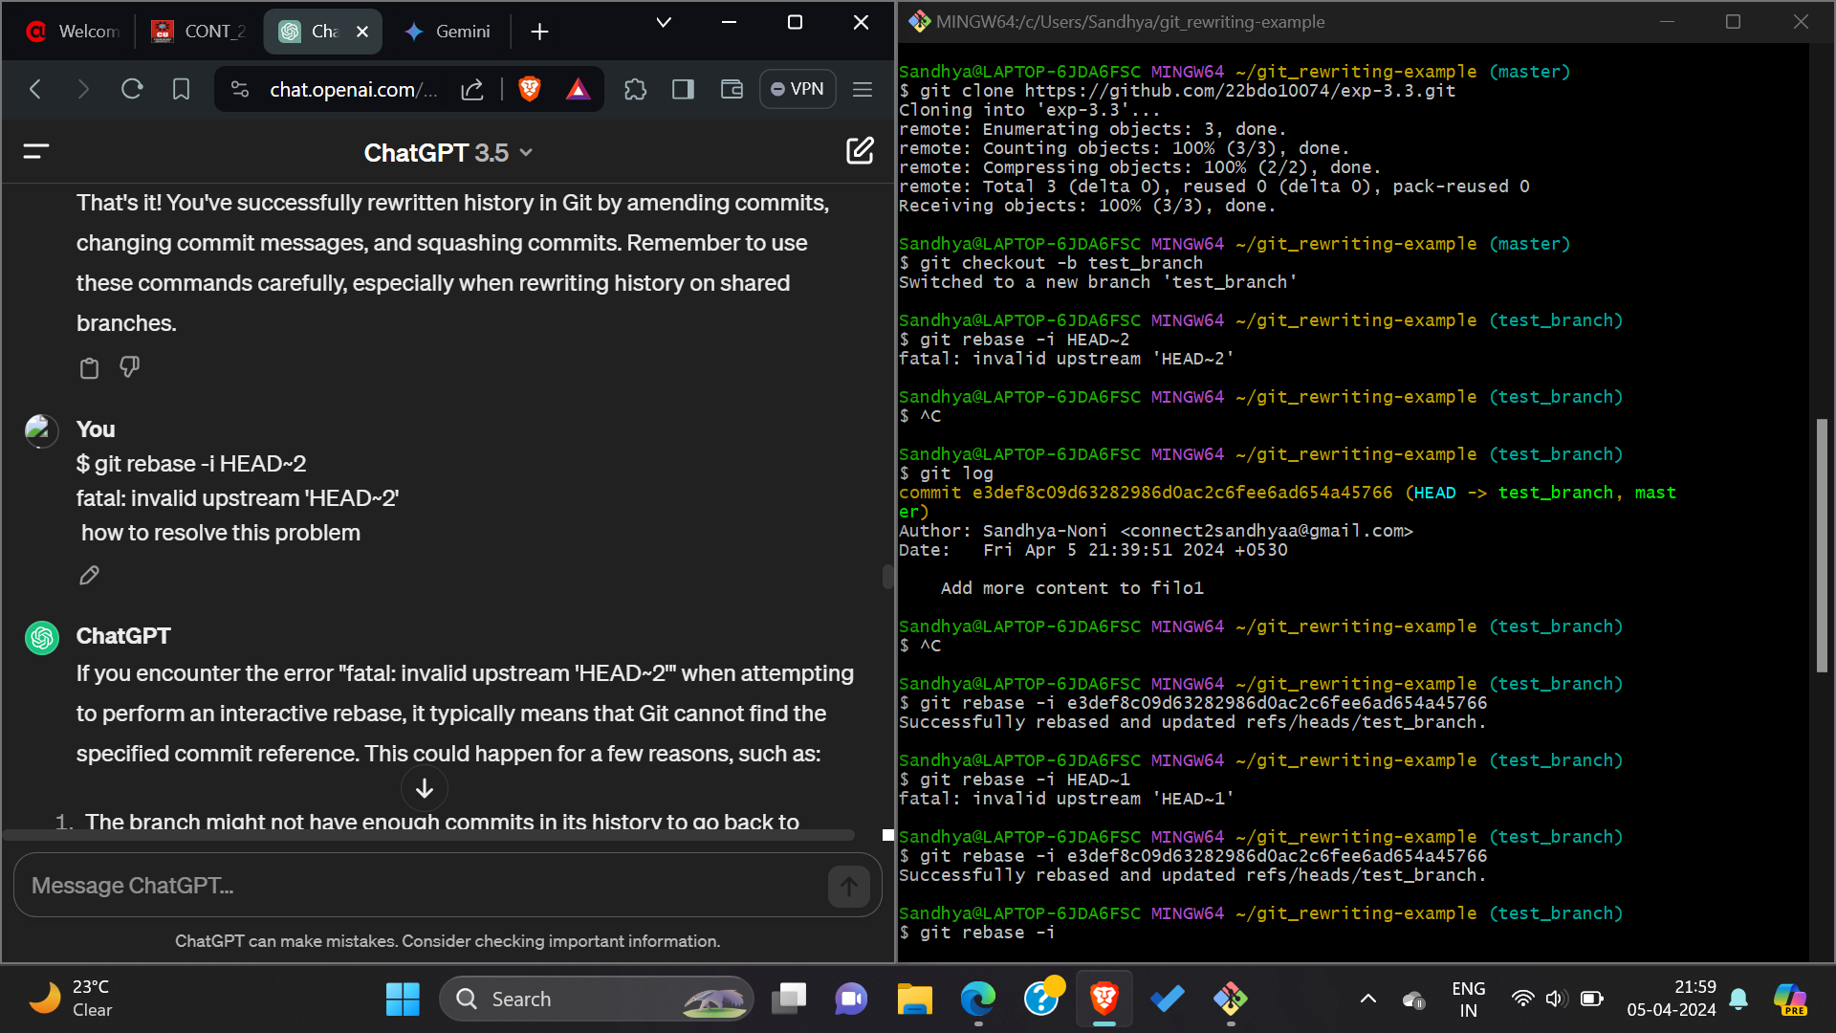

* **View History: After rewriting history, it's a good idea to view the commit history to ensure everything looks as expected.**

**Command: git log –oneline**

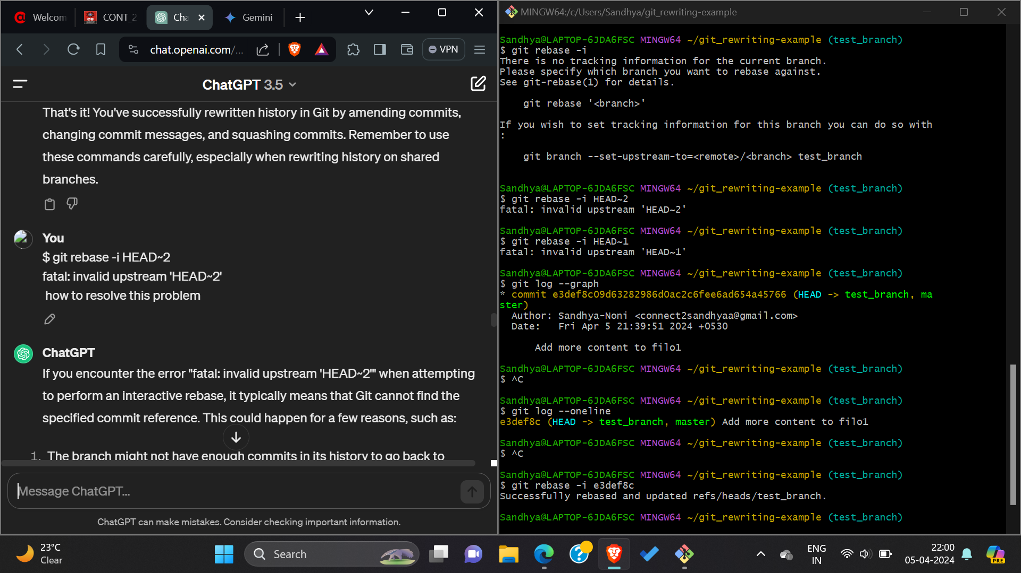

**8. Result/Output/Writing Summary:**

In this experiment, we have successfully rewritten history in Git by amending commits, changing commit messages, and squashing commits. Remember to use these commands carefully, especially when rewriting history.

**9.Learning outcomes (What I have learnt):**

1. Learnt about how to make repository and how to change directory.
2. Learnt how to add files and commit it.
3. Learnt about how to use git amend command.

**5.** Learnt how to see the history using git log command.

**Evaluation Grid (To be created as per the SOP and Assessment guidelines by the faculty):**

|  |  |  |  |
| --- | --- | --- | --- |
| Sr. No. | Parameters | Marks Obtained | Maximum Marks |
| 1. |  |  |  |
| 2. |  |  |  |
| 3. |  |  |  |
|  |  |  |  |